
FACULTY OF INFORMATION TECHNOLOGY AND ELECTRICAL ENGINEERING

Markus Heino
Seppo Pakonen
Jaakko
Mohammed Alanny

Notification management

Applied Computing Project 1
Computer science degree program
11/2016

PURPOSE OF THE PROJECT
The purpose of the project is to offer something that helps everyone in their everyday life. Our goal is to ease the stress of our users and give them a chance to fully focus on what they want. That is the reason why we are designing this application, which lets notifications to be delayed in the way user wants.

During the project we want to push to our limits as a group and as individuals, and this way offer as much as we can to our potential future customers. At the same time we want to scientifically study the user response of processing disruptive notifications of their smart devices, and understand our users even better.

While notifications keep an user informed and engaged with events around mobile applications, they do not have the same importance level to an user and the timing of a notification is also a factor in the perceived importance. _{[1, 2]}

The emphasis in the user experience of our application is to allow the most effective processing of notifications in the most user friendly way.

In the process of development we use a prioritization technique called the MoSCoW method, which allows the dynamic planning of the implementation. We are gathering all user feedback, which may affect also to minimum requirements. Getting enough user feedbacks is challenging, but we will put the effort to it in the early phase of the development to gain as much information as possible.

Key words: Notification management, android, notification delay

GROUP MEMBERS
Name | Student number | Email
Markus Heino | 2433882 | Markus.Heino@studen.oulu.fi
Seppo Pakonen | 2265199 | mail@sppp.heliohost.org
Jaakko | ------------- | ………………………………………
Mohammed Dalanny | 2510129 | mohammedalanny@gmail.com
The Project Manager | Heino Markus | Markus.Heino@student.oulu.fi

TABLE OF CONTENTS
PURPOSE OF THE PROJECT
GROUP MEMBERS
TABLE OF CONTENTS
GLOSSARY
1. DESIGN PROCESS 5
2. STATE OF THE ART 6
3. SCENARIOS AND USE CASES 7
4. REQUIREMENTS 9
5. SYSTEM DESIGN 10
6. INTERFACE DESIGN 12
7. USER COMMENTS 13
8. Analysis 14
9. RISK ASSESMENT 14
10. REFERENCES 15
11. CONTRIBUTIONS 15

GLOSSARY

Push notification | A push notification notifies the user of new messages or events in the application. The devices might show an icon and a message in the status bar. Tapping the notification opens the main view of the cause.
The MoSCoW method | This is a prioritization method, which has four categories for requirements. Categories are must have, should have, could have and would be nice to have.
The AWARE framework  NT | AWARE is an Android framework dedicated to instrument, infer, log and share mobile context information, for application developers, researchers and smartphone users. AWARE captures hardware-, software-, and human-based data.  Notification filter is an app from play-store that is similar to ours.

Design process

The group have been divided to the user interface team and the background system team.

The user interface team have created illustrations of menus of the application. They estimate different ways to show the most important aspects of the system while keeping the ease of use and the current state of smartphone applications in mind.

The background system team have focused to the system design and how to allow complex use cases later without making major changes to it. They have been reading publications about other similar studies and searching existing applications.

The user interface desing have been done using Balsamiq Mockups 3 software. Simple prototype have also been made using Java and Java Swing library.

Together the group have been negotiating about the connections between the user interface and the system. Many practical issues have also been as subjects of discussions. While the user interface

The user interface have to be simple, but the system behind it does not need to be. While the detailed features of the system are being found in the implementation phase, we might want to test them via the user interface. We concluded that advanced features would be available at a separate menu.

The coarse system design is handled in the following chapter, but the more detailed information will be available only in the following implementation document.

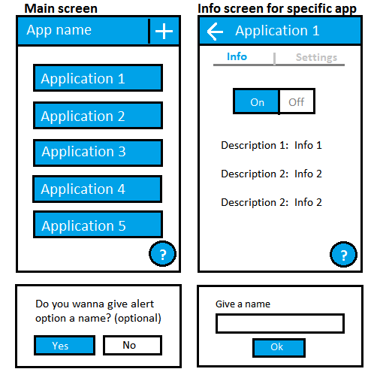

State of the art

In the literature, many studies cover notifications as a source of disruptions. They examine groups of people and their reactions to different notifications. In the results they take a stand on how people perceived notification importance or how to recognize automatically good times to push a notification.

The designed application as a notification manager have also been covered by many software patents. _{[4, 5]} That might cause difficulties in exporting the application to USA. The unique feature of our application is to read notifications later instead of just removing them.

The market place offers various similar solutions already. The most common feature is to allow blocking notifications of an application. Other features might include the customization of the sound and vibration or keeping the log of all notifications. Upcoming version of the Android operating system will also have a similar built-in feature.
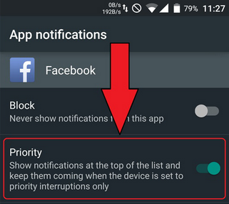

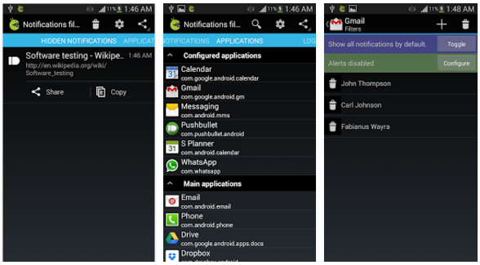

Scenarios and use cases

As a prelude to use cases, one user story might be, when Mary have been very annoyed about notifications during school. All she wants is a one click solution to fulfill her need for focused learning. She don't want to go through all settings in all apps to silence all useless notifications. She thinks it is time for action.

The “sunny day” use case is when a consumer wants to delay his notifications while he is in work. He goes to the Play-store and searches for notification manager. He finds our application and installs it. He runs the application, set his working hours and clicks 'delay'. All generally annoying notifications are then delayed until his working day ends.

The other use case is to filter working notifications after work. The steps are same as in previous, but instead of working hours he sets evening hours. Also he might want to customize settings and add messages from his employer and coworkers to be filtered.

A religious person with regular praying times might want to delay all notifications during praying time. He just adds multiple times and sets 'delay all'. Also a person going church regularly might want to do that.

Requirements

Functionality | For users:  - Access to the Play-store, to the F-Droid or to our github frontpage  - Android 2.3.3 (Android API 10)  For developers:  - Android-Studio  - Amd64 architecture PC or USB-connected Android device  - Access to GitHub
User interface | - Most important settings first
Usability | - Application must be working as expected without additional unwanted features
Security | - The feedback system must be anonymized  - The connection to our server must be encrypted  - The account service may not ask full name or other detailed credentials as they are completely unnecessary  - Connecting the application with social media services is worse option than using the device ID as a login, because highly anonymized data and avoiding unnecessary liabilities is the primary objective.  - Passwords must be checked by hash, not by plaintext
Management | - Our group have meeting with our supervisor once in every two weeks  - The group chat. Currently WhatsApp.
Standards  compliance | - Compliance with Play-store terms of service
Portability | - The code must be written entirely in Java to use it with other architectures than ARM.

System design
The main task is to intercept the normal way of flowing of notifications and use our configurable processing instead.

Notifications are being analyzed and classified. All information about the notification is collected and stored structurally in the memory.

The classified notification is then being matched to existing settings. If it does not match, then it will be forwarded and shown to the user as regularly. If it does match, then it will trigger the processing according to the setting.

The processing might cause the notification to be delayed, or modified or blocked entirely.

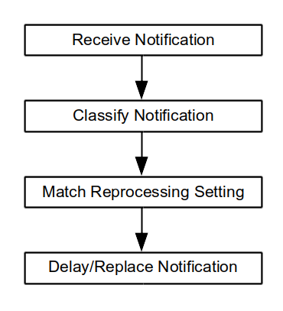

The whole application will be running from event based function calls instead of a fast loop, which is found e.g. in many games. If there is a need to call some function periodically, then scheduled system calls will be used.
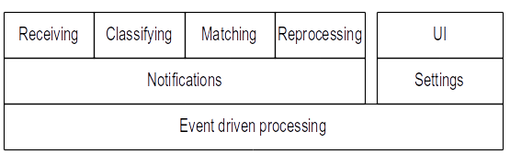

While the application itself does not require an internet connection, the user feedback system requires. Gathering the evaluation data is one of our primary objectives, and it requires a separate server and database connected to the Internet.

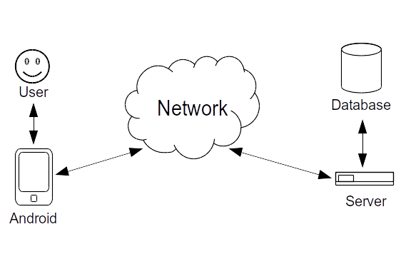

Interface design

User comments

To fully understand our future customers and their needs, we asked questions from our potential customers. The purpose of these questions was to give us more information about what kind of features users wish to have and what options the app should have to satisfy the needs of our clients.

Conversations with every potential client took only around 10-15 minutes to keep answers neutral. The answers pointed to the most important features in our app instantly, but they can also inspire in our future research.

Basically we asked:
- “If you had an app that could delay Facebook or Emails for a time, at what time would you use this ?( referred to examples like work and school)”.
- “Do you think this could help you to focus better on your workday or maybe in a meeting, if you couldn’t be disturbed by your phone unless it is an emergency?”
- “Which apps would be most important to delay and why these?”
- “Do you have anything you would like to add, now that you have a full view of what you could have”?

After feedback here are the main points our potential clients had:
- “It would be actually very nice to have an option to delay my facebook , Email, Whatsapp, notification when I go to class, but I’m worried that I won’t remember to turn it back on”
- “The settings I make in the app should be saved so I don’t have to change them every time”
- “App should be easy to use, like it could have a button to turn it on and off, maybe widget ?”
- “Delaying for an hour or to only and then the app would turn off by itself would be nice so I could just select “delay for 2 hours” and that’s all”

After research analyses, we are more enlightened as a group of our potential customer needs. We have a full picture of the features people want and how they should work in order to satisfy our clients in a best way possible.

Analysis

The annoyance of push notifications is scientifically known subject. Our project matches that in the analysing of the feedback data.

There are some similar application in Play-store _{[5, 6,]}. Notification was first one we found. First impression after opening the app is that you have to be using this app and you had to modify your apps. This is not what we want at all. We want that the user has an option to use the app if she/he wishes. There is no need to use it all the time and keep consuming your battery for nothing. Also NT (notification filter) had three steps that you had to do before using the app. We want offer max 3 different side.
Front page that includes easy access, on/off, the time for how long to delay.
Second page is for settings. Which apps you can delay and the checking is easy as it could be as shown in interface design.
The third page is for more detailed settings for certain apps. This page will be for more advanced users so not a mandatory for user.

As overall we want the user feel like this is just one app to help her/him in everyday life without thinking what kind of data will be this app collecting from me and how much it consumes my battery.
We want to offer something that is easy to use, don’t feel mandatory and can be used only when you want!

This project is a combination of known parts, both in marketing and scientific perspective, which makes it a good design.

Risk assesment

Brief | Not getting enough user feedback
Likelihood | Common
Impact | Minor
Preventive action | Making a working beta version in early phases of the development, and outreaching friends and relatives as test users.
Corrective action | We focus to data which doesn't require user interaction.

Brief | Enough easy functionality
Likelihood | Common
Impact | Moderate
Preventive action | Gathering as much data from potential users as possible. Making the app as simple as it can be.
Corrective action | Changing functionalities after feedback to satisfy customers.

References

- The myth of suble notifications (2014) UbiComp, pages 111-114
- Designing content-driven intelligent notification mechanisms for mobile applications (2015) UbiComp, pages 813-824.
- Temporal incoming communication notification management.
Patent US 8855723 B2
- Systems and methods for push notification management
Patent US 20150120849 A1
- Notifications filter. Android Play-store.
- Filter notifications (beta). Android Play-store.

Contributions

Name | Markus | Jaakko | Seppo | Mohammed
Illustrations | 9h | 3h | 3h
Meetings | 8h |  | 8h | 8h
Use cases | 1h |  | 12h | 2h
Document | 8h |  | 6h
Research | 12h |  | 12h | 10h
Additional |  |  |  | 10h
Total | 38h |  | 39h | 30h

Markus Heino

I started with mockups with Jaakko. In the first meeting we decided what kind of mockups will be the best for us and Jaakko started to modify mockups the way group decided. I started to work more on the design template and making sure template has everything it should. First a lot of research from design templates from others and then making very coarse version of my own for the group. Version had everything explained what we should have in our template and which ones are optional but from perspective mandatory for us. Template started to change after we added content on it and have been changing during the whole project. My main goals have been cover page, purpose of the project, analysis, risk assessments, mockups and making sure we have everything on the template that should be and even a bit more. Everything been proofread by every member and there for text have been changing a bit from every section.

